Write a program to input 2 numbers from the user and display their addition, multiplication, subtraction, and division.

import java.util.Scanner;

public class ArithmeticOperations{ public static void main(String[] args){

Scanner scanner = new Scanner(System.in);

System.out.print("Enter the first number: "); int num1 = scanner.nextInt();

System.out.print("Enter the second number: "); int num2 = scanner.nextInt();

int sum = num1 + num2;

System.out.println("Sum of the numbers: " + sum);

int product = num1 * num2;

System.out.println("Product of the numbers: " + product);

int difference = num1 - num2;

System.out.println("Difference of the numbers: " + difference);

float quotient = (float) num1 / num2; System.out.println("Quotient of the numbers: " + quotient);

}

}

Output-

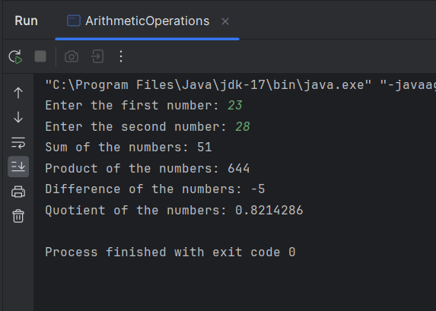

Write a program to accept value of marks of 5 subjects and calculate percentage and display it.

import java.util.Scanner;

public class MarksPercentage {

public static void main(String[] args) { Scanner scanner = new Scanner(System.in);

System.out.println("Enter marks of 5 subjects: "); int totalMarks = 0;

for (int i = 0; i < 5; i++) {

System.out.print("Enter marks for subject " + (i + 1) + ": "); int marks = scanner.nextInt();

totalMarks += marks;

}

double percentage = (double) totalMarks / 500 * 100;

System.out.println("Percentage: " + percentage);

}

}

Output

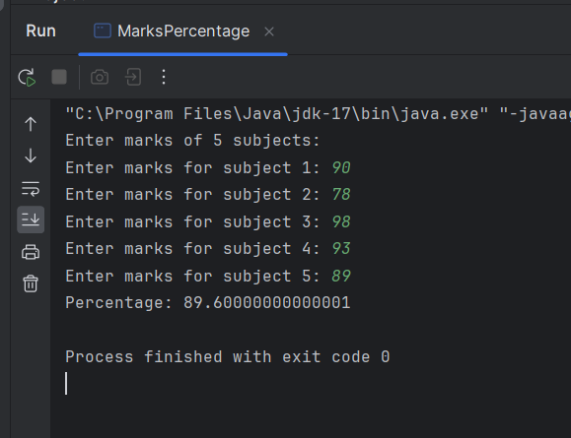

Write a program to assign value of radius then calculate the area and perimeter of circle, area of triangle and area of rectangle by using method calling (use arithmetic promotion).

import java.util.Scanner; public class Area {

static double area_of_Triangle()

{

Scanner sc = new Scanner(System.in);

System.out.println("Enter The Height of the Triangle = ");

double Height = sc.nextDouble();

System.out.println("Enter The Base of the Triangle = ");

double Base = sc.nextDouble();

double area_of_triangle = (Height*Base)/2;

return (area_of_triangle);

}

static double area_of_Rectangle()

{

System.out.println("Enter The one side of the Rectangle = ");

Scanner sc = new Scanner(System.in);

double Side_1 = sc.nextDouble();

System.out.println("Enter The second side of the Rectangle = ");

double Side_2 = sc.nextDouble();

double area_of_Rectangle = Side_1*Side_2;

return (area_of_Rectangle);

}

static double area_of_Circle()

{

Scanner sc = new Scanner(System.in);

System.out.println("Enter The Radius of the Circle = ");

double Radius = sc.nextDouble();

double area_of_Circle = 3.142*Radius*Radius;

return (area_of_Circle);

}

static double area_of_Square()

{

Scanner sc = new Scanner(System.in);

System.out.println("Enter The Side of the Square = ");

double Side = sc.nextDouble();

double area_of_Square = Side*4;

return (area_of_Square);

}

public static void main(String[] args)

{

System.out.println("The Area of Triangle is"+Area.area_of_Triangle()+" sq.unit");

System.out.println("");

System.out.println("The Area of Rectangle is = "+Area.area_of_Rectangle()+" sq.unit");

System.out.println("");

System.out.println("The Area of Circle is = "+Area.area_of_Circle()+" sq.unit");

System.out.println("");

System.out.println("The Area of Square is = "+Area.area_of_Square()+" sq.unit");

}

}

Output -

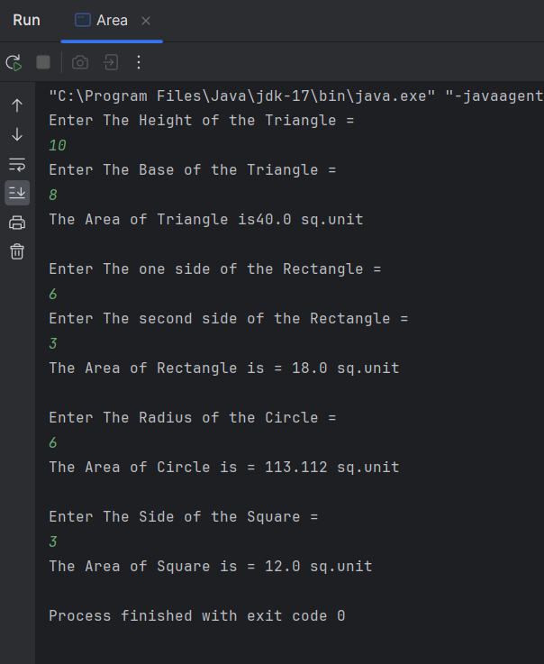

//Experiment No 2

//Program 1

Write a program to perform mathematical operations by using different methods of Math class.

import java.util.*;

public class Mathoperationui

{

static int Max()

{

Scanner sc = new Scanner(System.in);

System.out.println("Let's Find The Maximum of Two Numbers");

System.out.println("Enter The Value Of a - ");

int a = sc.nextInt();

System.out.println("Enter The Value Of b - ");

int b = sc.nextInt();

return Math.max(a,b);

}

static int Min()

{

Scanner sc = new Scanner(System.in);

System.out.println("Let's Find The Minimum of Two Numbers");

System.out.println("Enter The Value Of a - ");

int a = sc.nextInt();

System.out.println("Enter The Value Of b - ");

int b = sc.nextInt();

return Math.min(a,b);

}

static int Roundup()

{

Scanner sc = new Scanner(System.in);

System.out.println("Enter The Value to be Rounded - ");

float a = sc.nextFloat();

return Math.round(a);

}

public static void main(String[] args)

{

System.out.println("The max is = "+ Max());

System.out.println("The min is = "+ Min());

System.out.println("The Rounded Value is = "+ Roundup());

}

}

Output -

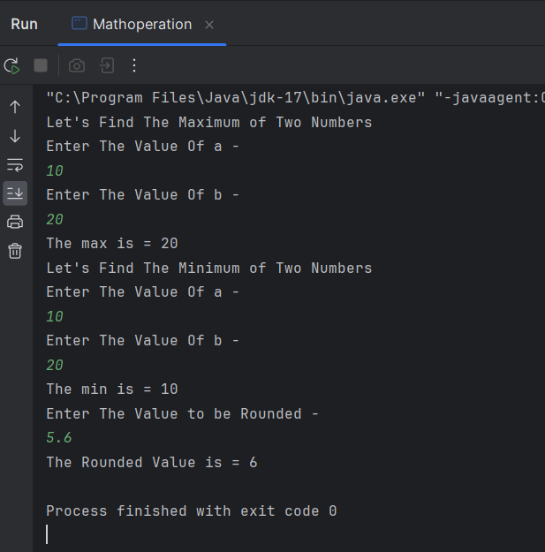

//Experiment No 2

//Program 2

Write a program to accept the string from the user to perform string related operations by using different methods of String class.

import java.util.*;

class Stringoperation {

public static void main(String[] args) { Scanner sc = new Scanner(System.in);

System.out.println("Enter Your First Name:-"); String str1 = sc.nextLine(); System.out.println("Enter Your Last Name:- "); String str2 = sc.nextLine();

// Concatenate two strings String str3 = str1 + " " + str2;

System.out.println("The Concatenation of the string is: " + str3);

// Get the length of a string int length = str1.length();

System.out.println("The Length of the String is: " + length);

// Find the index of a character in a string int index = str1.indexOf('A');

System.out.println("A character is at index:- " + index);

// Convert a string to uppercase String str4 = str3.toUpperCase();

System.out.println("UpperCase of the string is:- " + str4);

// Convert a string to lowercase String str5 = str3.toLowerCase();

System.out.println("LowerCase of the string is:- " + str5); // Outputs hello, world!

sc.close();

}

}

Output -

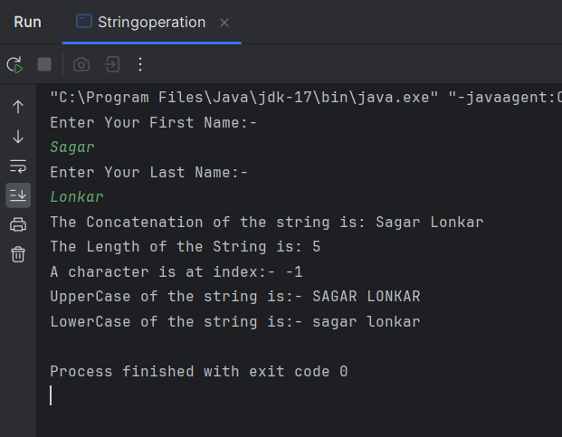

//Experiment No 3

//Program 1 & 2

1. Write a program to perform addition by changing the number of arguments using function overloading.
2. Write a program to perform multiplication by changing the data types using function overloading.

public class MethodOverloading {

public static int sum(int a,int b)

{

int c = a + b;

return c;

}

public static double sum(double a,double b,double c)

{

double d = a + b + c;

return d;

}

public static int multiplication(int a,int b)

{

int c = a*b;

return c;

}

public static double multiplication(double a,double b,double c)

{

double d = a*b*c;

return d;

}

public static void main(String[] args) {

System.out.print("\nThe Sum Of The Two Number is " + MethodOverloading.sum(5, 2));

System.out.print("\nThe Sum Of The Three Number is " + MethodOverloading.sum(5, 2, 5));

System.out.print("\nThe Multiplication Of The Two Number is " + MethodOverloading.multiplication(5, 2));

System.out.print("\nThe Multiplication Of The Three Number is " + MethodOverloading.multiplication(5, 2, 5));

}

}

Output

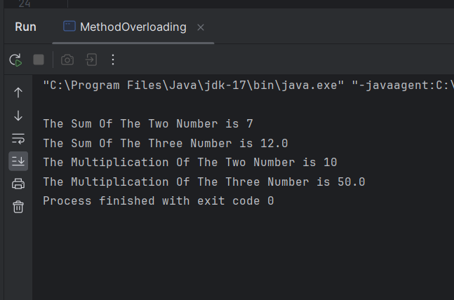

//Experiment No 3

//Program 3

Write a program to declare class student having data member id and name, initialized it using default constructor for two object of class and display all records.

public class StudentConstructor {

int Roll_No;

String name;

float marks;

StudentConstructor(int RN, String N, float M)

{

Roll_No = RN;

name = N;

marks = M;

}

void display()

{

System.out.print("\nRoll Number of the student is :- " + Roll_No);

System.out.print("\nName of the student is :- " + name);

System.out.print("\nMarks of the student is :- " + marks);

System.out.print("\n");

}

public static void main(String[] args)

{

|  |  |  |  |  |  |  |
| --- | --- | --- | --- | --- | --- | --- |
|  |  | StudentConstructor | s1 | = | new | StudentConstructor(02,"Sudarshan",100); |
|  |  | StudentConstructor | s2 | = | new | StudentConstructor(10,"Shubham",99); |
|  |  | StudentConstructor | s3 | = | new | StudentConstructor(02,"Prasad",98); |
|  |  | s1.display(); |  | | | |
|  |  | s2.display(); |
|  | } | s3.display(); |
| } |  |  |

-Output

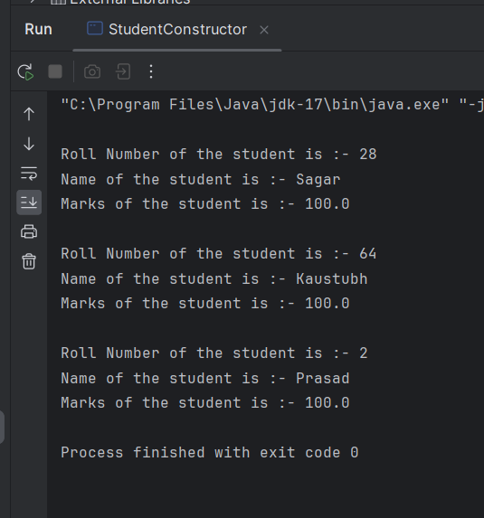

//Experiment 3

//Program 4

Write a program to declare class Book having data member id, name and price, initialized it using parameterized constructor for two object of class and display all records

class Book {

int id; String name; double price;

public Book(int id, String name, double price) { this.id = id;

this.name = name; this.price = price;

}

public void display() { System.out.println("Book ID: " + id); System.out.println("Book Name: " + name); System.out.println("Book Price: " + price);

}

}

public class BookRecords {

public static void main(String[] args) {

Book book1 = new Book(101, "Let us C", 250.50);

Book book2 = new Book(102, "Python Programming", 350.75);

book1.display(); book2.display();

}

}

Output -

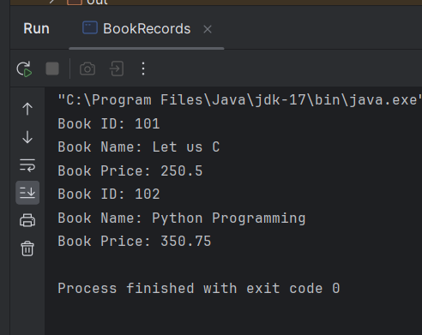

//Experiment 4

//Program 1

Write a program to accepts three numbers from user and find largest number.

import java.util.*;

public class ControlStatement1

{

public static void main(String[] args)

{

System.out.println("Enter The First Integer\na = ");

Scanner sc = new Scanner(System.in);

int a = sc.nextInt();

System.out.println("Enter The Second Integer\nb = ");

int b = sc.nextInt();

System.out.println("Enter The Third Integer\nc = ");

int c = sc.nextInt();

sc.close();

if(a>b) {

if(b>c) {System.out.println(a + " Is The Largest Number");}

else {System.out.println(c + " Is The Largest Number");}

}

|  |  |  |  |  |
| --- | --- | --- | --- | --- |
|  | else | { |  | |
|  |  |  | if(b>c) {System.out.println(b + " | Is The Largest Integer ");} |
|  |  |  | else {System.out.println(c + " Is | The Largest Number");} |
|  |  | } |  |  |
| } | } |  |  |  |

Output

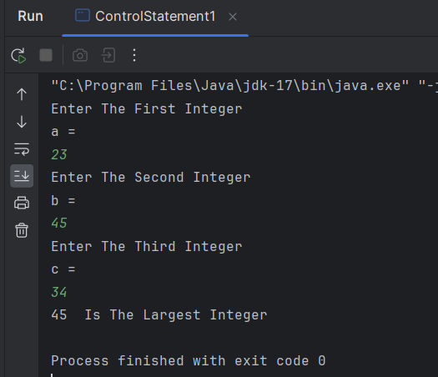

//Experiment 4

//Program 2

Write a program to accept number from user and calculate factorial of given number.

import java.util.*;

public class ControlStatement2 {

public static void main(String[] args) {

System.out.println("Enter An Integer To Find The Factorial Of It.\na = ");

|  |  |  |
| --- | --- | --- |
|  |  | Scanner sc = new Scanner(System.in); |
|  |  | int a = sc.nextInt(); |
|  |  | sc.close(); |
|  |  | int fact = 1; |
|  |  | int i; |
|  |  | for(i=a;i>0;i--) |
|  |  | { |
|  |  | fact = fact*i; |
|  |  | } |
|  |  | System.out.println("The Factorial Is = " + fact); |
| } | } |  |

-Output -

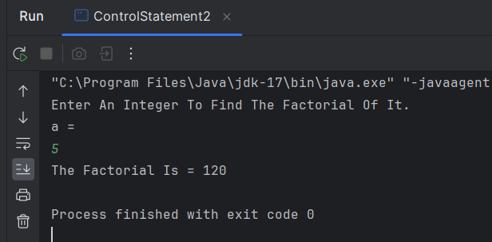

//Experiment 4

//Program 3

Write a program to accept number from user and check number is palindrome or not.

import java.util.Scanner;

public class ControlStatement3 {

public static void main(String[] args) {

System.out.println("Enter An Integer To it is palindrome or Not.\na = ");

|  |  |  |
| --- | --- | --- |
|  |  | Scanner sc = new Scanner(System.in); |
|  |  | int a = sc.nextInt(); |
|  |  | sc.close(); |
|  |  | String original = String.valueOf(a); |
|  |  | String rev = ""; |
|  |  | char ch ; |
|  |  | for(int i=0; i<original.length(); i++) |
|  |  | { |
|  |  | ch= original.charAt(i); |
|  |  | rev= ch+rev; |
|  |  | } |
| // |  | System.out.println(original); |
| // |  | System.out.println(rev); |

if(original.equals(rev)) {System.out.println("The Number Is Palindrome");} else {System.out.println("The number is not palindrome");}

}

}

Output-

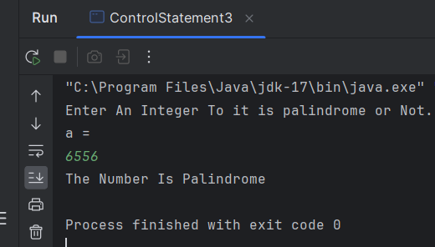

//Experiment 4

//Program 4

Write a program to accept number from user and check number is Armstrong or not.

import java.util.Scanner;

public class ArmstrongNumber {

public static void main(String[] args) { int num,org_no,r,res=0;

Scanner sc=new Scanner(System.in); System.out.println("Enter a Number to Check Armstrong "); num=sc.nextInt();

org_no=num; while(org_no!=0)

{

r=org_no%10; res+=Math.pow(r,3); org_no/=10;

}

if(res==num)

{

System.out.println("It is Armstrong Number");

}

else

{

System.out.println("It is not Armstrong Number");

}

}

}

Output

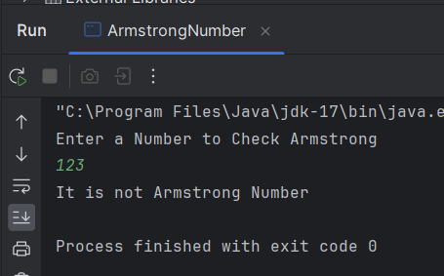

//Experiment 4

//Program 5

Write a program to accept number from user and check number is prime or not.

import java.util.Scanner; public class ControlStatement4 {

public static void main(String[] args)

{

System.out.println("Enter An Integer To check Whether it is Prime or Not.\na = ");

|  |  |  |
| --- | --- | --- |
|  |  | Scanner sc = new Scanner(System.in); |
|  |  | int a = sc.nextInt(); |
|  |  | sc.close(); |
|  |  | int prime = 1; |
|  |  | for(int i = 2;i<a;i++) |
|  |  | { |
|  |  | if(a%i==0) |
|  |  | { |
|  |  | prime = 0; |
|  |  | break; |
|  |  | } |
|  |  | } |
|  |  | if(prime==0) {System.out.println("The Number Is Not Prime");} |
|  |  | else {System.out.println("The Number Is Prime");} |
| } | } |  |

Output

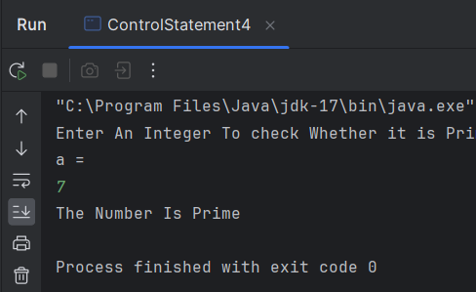

//Experiment 5

//Program 1

Write a program to accept ‘n’ number from user to store in array and finds largest number in an array.

import java.util.Scanner;

public class LargestNumber {

public static void main(String[] args) { Scanner scanner = new Scanner(System.in);

System.out.print("Enter the number of elements: "); int n = scanner.nextInt();

int[] arr = new int[n];

System.out.println("Enter the elements:"); for (int i = 0; i < n; i++) {

arr[i] = scanner.nextInt();

}

int max = arr[0];

for (int i = 1; i < arr.length; i++) { if (arr[i] > max) {

max = arr[i];

}

}

System.out.println("The largest number is: " + max);

}

}

-Output

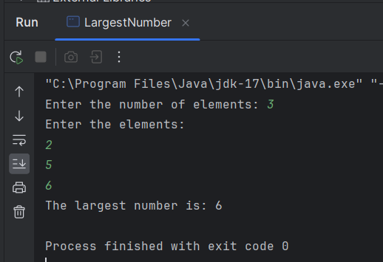

//Experiment 5

//Program 2

Write a program accept ‘n’ number store in array and perform linear search.

import java.util.Scanner;

public class LinearSearch {

public static void main(String[] args) { Scanner scanner = new Scanner(System.in);

// Get the number of elements in the array System.out.print("Enter the number of elements: \n"); int n = scanner.nextInt();

// Create an array of size n int[] arr = new int[n];

// Read the array elements System.out.print("Enter the array elements: \n"); for (int i = 0; i < n; i++) {

arr[i] = scanner.nextInt();

}

// Get the element to search for System.out.print("Enter the element to search for: "); int key = scanner.nextInt();

// Perform linear search

int index = linearSearch(arr, key);

// Check if the element was found if (index != -1) {

System.out.println("Element found at index: " + index);

} else {

System.out.println("Element not found.");

}

}

public static int linearSearch(int[] arr, int key) { for (int i = 0; i < arr.length; i++) {

if (arr[i] == key) { return i;

}

}

return -1;

}

Output

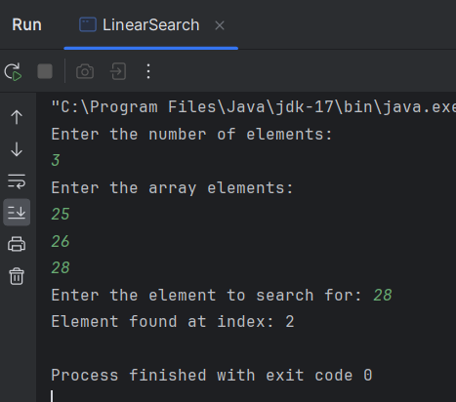

//Experiment No 5

//Program 3

Write a program to accept 3x3 Matrix and calculate addition of two matrixes and display it.

import java.util.*;

public class Matrix {

public static void main(String[] args)

{

|  |  |  |  |  |  |  |  |  |  |
| --- | --- | --- | --- | --- | --- | --- | --- | --- | --- |
|  |  |  | int | | A[][] | | =new | int[3][3]; | |
|  |  |  | int | | B[][] | | =new | int[3][3]; | |
|  |  |  | int | | C[][] | | =new | int[3][3]; | |
|  |  |  | Scanner SC = new Scanner(System.in); | | | | | |  |
|  |  |  | System.out.println("Enter The Elements Of Matrix for(int i=0; i<3;i++) {  for(int j=0; j<3;j++) {  A[i][j] = SC.nextInt();  }  } | | | | | | A"); |
|  |  |  | System.out.println("Enter The Elements Of Matrix for(int i=0; i<3;i++) {  for(int j=0; j<3;j++) {  B[i][j] = SC.nextInt();  }  } | | | | | | B"); |
|  |  |  | System.out.println("Display Matrix A"); for(int i=0; i<3;i++) {  for(int j=0; j<3;j++) {  System.out.print(A[i][j] +" "); | | | | | |  |
|  |  |  | }  System.out.println();  } | | | | | |  |
|  |  |  | System.out.println("Display Matrix B"); | | | | | |  |
|  |  |  |  | for(int  { | | i=0; i<3;i++)  for(int j=0; j<3;j++) | | | |
|  |  |  |  |  | | {  System.out.print(B[i][j] +" "); | | | |
|  |  |  | } |  | | }  System.out.println(); | | | |

|  |  |  |  |  |
| --- | --- | --- | --- | --- |
|  |  |  |  | |
|  |  |  | System.out.println("Addition of the matrix | A and B:"); |
|  |  |  | for(int i=0;i<3 ; i++) {  for(int j=0;j<3;j++){ |  |
|  | } |  | C[i][j]=A[i][j]+B[i][j];  System.out.print(C[i][j]+"  }  System.out.println();  }  SC.close(); | "); |
| } |  |  |  |  |

Output-

Enter The Elements Of Matrix A 1

2

3

4

5

6

7

8

9

Enter The Elements Of Matrix B 9

8

7

6

5

4

3

2

1

Display Matrix A 1 2 3

4 5 6

7 8 9

Display Matrix B 9 8 7

6 5 4

3 2 1

Addition of the matrix A and B:

|  |  |  |
| --- | --- | --- |
| 10 | 10 | 10 |
| 10 | 10 | 10 |
| 10 | 10 | 10 |

//Experiment No 5

//Program 4

Write a program to declare class Employee having data member emp_id, name and salary. Accept records for 5 employee and display that records whose salary is greater than 5000.

import java.util.Scanner; class Employee {

int employee_id; String name; double salary;

Employee(int id, String name, double salary) { this.employee_id = id;

this.name = name; this.salary = salary;

}

public void displayEmployeeDetails() { System.out.println("Employee ID: " + employee_id); System.out.println("Name: " + name); System.out.println("Salary: " + salary); System.out.println();

}

}

public class EmployeeRecords {

public static void main(String[] args) { Scanner sc = new Scanner(System.in);

System.out.println("Enter employee records:"); for (int i = 0; i < 2; i++) {

System.out.println("Enter employee ID: "); int id = sc.nextInt();

System.out.println("Enter employee name: "); String name = sc.nextLine();

sc.nextLine();

System.out.println("Enter employee salary: "); double salary = sc.nextDouble();

Employee employee = new Employee(id, name, salary); if (employee.salary > 5000) {

employee.displayEmployeeDetails();

}

}

sc.close();

}

}

Output

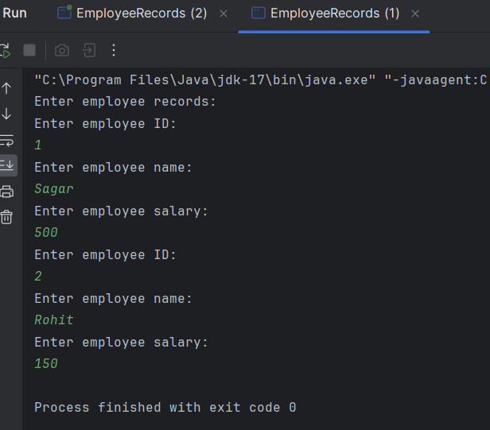

//Experiment No 6

//Program 1

Write a program to implement following inheritance. Assume suitable methods. Superclass

Class Name: Student

Member variables: Roll_no, Name Subclass:

Class Name: Library

Member variables: Member_No

class Student {

private int roll_no; private String name;

public Student(int roll_no, String name) { this.roll_no = roll_no;

this.name = name;

}

public int getRoll_no() { return roll_no;

}

public void setRoll_no(int roll_no) { this.roll_no = roll_no;

}

public String getName() { return name;

}

public void setName(String name) { this.name = name;

}

}

class Library extends Student { private int member_no;

public Library(int roll_no, String name, int member_no) { super(roll_no, name);

this.member_no = member_no;

}

public int getMember_no() { return member_no;

}

public void setMember_no(int member_no) { this.member_no = member_no;

}

}

public class Inheritance1 {

public static void main(String[] args) {

Library student1 = new Library(02, "Sudarshan", 2003);

System.out.println("Roll No: " + student1.getRoll_no()); System.out.println("Name: " + student1.getName()); System.out.println("Member No: " + student1.getMember_no());

}

}

Output

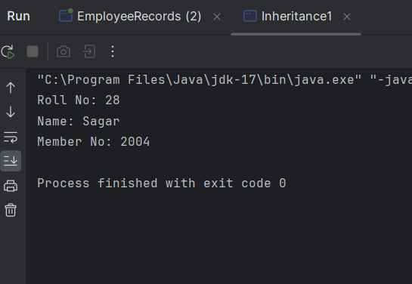

//Experiment No 6

//Program 2

Write a program to implement following multilevel inheritance. Assume suitable methods.

1. Class Name: Student

Member variables: Roll_no, Name

1. Class Name: Marks

Member variables: Marks1, Marks2,Total

1. Class Name: Result

Member variables: Percentage

class Student {

int roll_no; String name;

Student(int roll_no, String name) { this.roll_no = roll_no; this.name = name;

}

}

class Marks extends Student { int marks1;

int marks2; int total;

Marks(int roll_no, String name, int marks1, int marks2) { super(roll_no, name);

this.marks1 = marks1; this.marks2 = marks2; this.total = marks1 + marks2;

}

}

class Result extends Marks { double percentage;

Result(int roll_no, String name, int marks1, int marks2) { super(roll_no, name, marks1, marks2);

this.percentage = (double) this.total / 200 * 100;

}

void display() {

System.out.println("Roll No: " + roll_no); System.out.println("Name: " + name); System.out.println("Marks1: " + marks1);

System.out.println("Marks2: " + marks2); System.out.println("Total: " + total); System.out.println("Percentage: " + percentage);

}

}

public class Inheritance2 {

public static void main(String[] args) {

Result s1 = new Result(2, "Sudarshan", 91, 92); s1.display();

}

}

Output

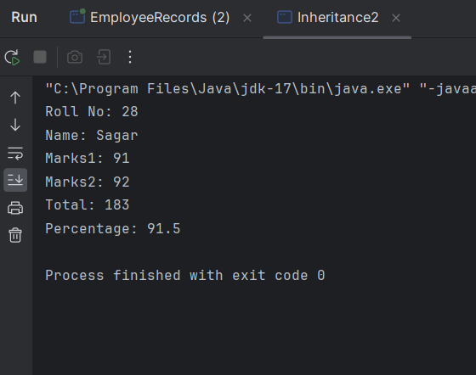

Write a Java program to create a base class Bank with method with interest_rate (). Create two subclasses SBI and ICICI. Override the interest_rate () method to find out interest rate.

class Bank {

public void interestRate() {

System.out.println("Base Bank Interest Rate: 5%");

}

}

class SBI extends Bank {

public void interestRate() { System.out.println("SBI Interest Rate: 8%");

}

}

class ICICI extends Bank { public void interestRate() {

System.out.println("ICICI Interest Rate: 7%");

}

}

public class IntrestRate {

public static void main(String[] args) { Bank sbi = new SBI(); sbi.interestRate();

Bank icici = new ICICI(); icici.interestRate();

}

}

Output-

SBI Interest Rate: 8% ICICI Interest Rate: 7%

//Experiment 7

//Program 1

Write a program to declare class Shape then calculate Area of circle, Area of Triangle, Area of Rectangle and area of Square using Constructor overloading.

public class Shape {

private double radius, length, width, base, height;

// Constructor for circle public Shape(double radius) {

this.radius = radius;

}

// Constructor for rectangle

public Shape(int length, int width) { this.length = length;

this.width = width;

}

// Constructor for triangle

public Shape(double base, double height) { this.base = base;

this.height = height;

}

// Constructor for square public Shape(int side) {

this.length = side; this.width = side;

}

// Method to calculate area of circle public double calculateAreaCircle() { return Math.PI * radius * radius;

}

// Method to calculate area of rectangle public double calculateAreaRectangle() {

return length * width;

}

// Method to calculate area of triangle public double calculateAreaTriangle() {

return 0.5 * base * height;

}

// Method to calculate area of square public double calculateAreaSquare() {

return length * length;

}

public static void main(String[] args) {

// Create objects for circle, rectangle, triangle, and square Shape circle = new Shape(5.0);

Shape rectangle = new Shape(10, 5); Shape triangle = new Shape(6.0, 8.0); Shape square = new Shape(4);

// Calculate and display the area of each shape System.out.println("Area of circle: " + circle.calculateAreaCircle()); System.out.println("Area of rectangle: " +

rectangle.calculateAreaRectangle()); System.out.println("Area of triangle: " +

triangle.calculateAreaTriangle());

System.out.println("Area of square: " + square.calculateAreaSquare());

}

}

Output-

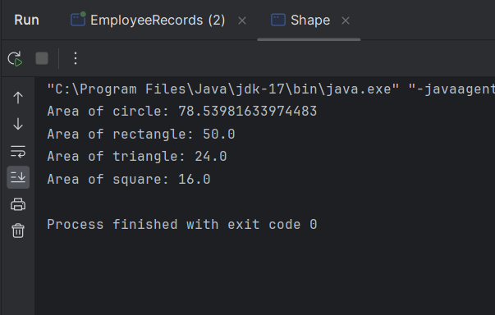

//Experiment No 7

//Program 3

Write a program to declare class Box with data member length, width, height, initialized three object using different constructors and calculate Volume of Box and display records.

class Box {

// Data members double length; double width; double height;

// Default constructor Box() {

length = 0.0;

width = 0.0;

height = 0.0;

}

// Parameterized constructor Box(double l, double w, double h) {

length = l; width = w; height = h;

}

// Method to calculate volume of the box double volume() {

return length * width * height;

}

}

public class BoxDemo {

public static void main(String[] args) {

// Create three objects using different constructors Box box1 = new Box(); // Default constructor

Box box2 = new Box(10.0, 20.0, 30.0); // Parameterized constructor Box box3 = new Box(15.0, 25.0, 35.0); // Parameterized constructor

// Calculate and display volume of each box

|  |  |  |  |  |  |  |  |
| --- | --- | --- | --- | --- | --- | --- | --- |
|  | | System.out.println("Volume | of | Box1: | " | + | box1.volume()); |
| System.out.println("Volume | of | Box2: | " | + | box2.volume()); |
| } | } | System.out.println("Volume | of | Box3: | " | + | box3.volume()); |

-Output

